İZMİR UNIVERSITY OF ECONOMICS

FACULTY OF ENGINEERING

COMPUTER/ SOFTWARE ENGINEERING

FENG 497 PROJECT REPORT



.

AUTHOR(S): EGE ERGÜN, CEVDET ÖZKAN AY, SEVİNÇ KAYA, BARIŞ SUSAN

SUPERVISOR: TURHAN TUNALI

**ABSTRACT** **5**

**INTRODUCTION** **5**

2.1. PROBLEM STATEMENT 5

2.2. MOTIVATION 6

**LITERATURE REVIEW** **6**

3.1. Agribros.market 6

Similarities and Differences with Our Project 7

3.2. agro-market24.eu 8

Similarities and Differences with Our Project 9

3.3. Wildkale.com 11

Similarities and Differences with Our Project 11

3.4. ditap.gov.tr 12

Similarities and Differences with Our Project 12

3.5. Efarm.cm 13

Similarities and Differences with our Project 14

3.6. Tarimziraat.com 15

Similarities and Differences with Our Project 16

3.7. PULLUK.COM 16

Similarities and Differences with Our Project 17

3.8. Çitfçideneve.com 18

Similarities and Differences with Our Project 19

**METHODOLOGY** **19**

4.1 Requirements Specifications 19

4.1.1. Functional Requirements 19

Registry 19

Return to User 20

Show Progress 20

Expiration Date 20

Baseline Descriptors 21

Filtration 21

Categories 22

Update/Remove 22

Price Change 23

Ranking 23

4.1.2. Non-Functional Requirements 23

Availability 23

Accuracy 23

Efficiency 24

Security 24

Usability 24

Scalability 24

Performance 24

Privacy 24

Functionality 24

Flexibility 24

Robustness 24

4.2. Design Specifications 25

4.2.1. General Description 25

4.2.1.1. Product Perspective 25

4.2.1.2. General Constraints 25

4.2.1.3. Assumptions 25

4.2.2. Screen Flows 25

4.2.2.1.Login/Register Page 25

4.2.2.2.Contact Link 27

4.2.2.3.Info Link 27

4.2.2.4.Login Page 28

4.2.2.5.Forgot Password 29

4.2.2.6.Registry Page 29

4.2.2.7. Main Page 30

4.2.2.8. Update Profile Page 31

4.2.2.9. My Products Page 31

4.2.2.10. Enter Product Information Page 32

4.2.2.11.Product List Page 33

4.2.2.12.Market Place Page 33

4.2.2.13.View Product Page 34

4.2.3. Design Details 34

4.2.3.1. UML Activity Diagram 34

4.2.3.2. Data Flow Diagram 36

4.2.3.2.1. Context Diagram 36

4.2.3.2.2. Data Flow Diagram Level 0 37

4.2.3.2.3. Data Flow Diagram Level 1 38

4.2.3.3. Network Diagram 38

4.2.3.4. Class Diagram 39

4.2.3.5. Use Case Diagram 39

4.2.3.5.1. Use Case Diagram Main Page 39

4.2.3.5.2. Use Case Diagram User Interactions 40

4.2.3.5.1. Use Case Diagram Admin Interactions 41

**CONCLUSION** **42**

**REFERENCES** **43**

# ABSTRACT

In this project, we chose a topic that is related to the farming market to help customers, sellers, and producers. This project has different opportunities for marketing between producers, sellers, and customers. Also, an online market is necessary for shopping to see fair prices. Our main aim is to prevent intermediaries from making unfair profits from producers, sellers, and customers. Thereby people can shop without a middleman and sell their products directly to the buyers. And by doing so the producers won’t lose any money paying off middlemen and for the buyers because there is no money lost on the middlemen, the price they pay is the actual price of the product which is fairly lower than any other ones that had to switch between a lot of people to get to the market.

# INTRODUCTION

It probably does not surprise you to hear that most profitable farms are large industrialized operations. Because they have their brands they don't need any mediator to sell their products. However small farm businesses need a mediator to sell their products. Because of this problem, farmers must sell their products below the market price. All small farms are losing money because of this problem. Small farm businesses leave farming this causes competition problems. Competition is important for customers because it gives the customer more choice, better prices, and quality. For the small farm businesses, we plan to help them using the power of the internet. Nowadays everything can be sold on the internet. Farmers can sell their products directly to grocery stores or restaurants. Our website helps small farms advertise their products easily. This is an advantage for other grocery stores and restaurants because they can easily reach a lot of variety and quality products. Our website will be free for all users. We are planning to gain money from advertisements and donations. Because the most important thing in our system is the users. More users equal more products and more competition. Our country is very suitable for farming however people leaving farming due to unfair mediator prices crippling their economy. If our system is successful, production variety will increase and everybody can profit from it.

## 2.1. PROBLEM STATEMENT

In this project, our main aim is to design a system that helps to prevent intermediaries between producers while selling products. Producers can advertise their products in this system directly to buyers without an intermediary. Therefore users of this system will not pay extra commissions to intermediaries. Producers can determine their products’ price and stock as they want. And buyers can buy whatever they want according to producers’ inventories. Thanks to our system, every user of our system will not spend extra money on commissions. Therefore producers and buyers can shop with ease by using our system.

## 2.2. MOTIVATION

Our project is a potential solution for the injustice of agricultural activities in our country. In our country, farmers cannot earn enough wages to continue their lives from the product they grow. People also complain about the prices of fruits and vegetables in large grocery stores. In other words, neither the producer nor the customer who demands the goods is satisfied. The reason for this is very simple. Intermediaries collect goods cheaply and sell them to the grocery store at high prices. Our project has set out to be the solution to this issue. Farmers will be able to put their products on our site and easily reach their customers. Customers will be able to contact sellers for their goods in bulk. The fact that the farmers and the customers are in the same location will also provide a separate advantage, if the customer wants, they can do the wholesale purchase without the cost of transportation. If the farmer and the customer are in different locations, thanks to our project, they will be able to communicate and negotiate among themselves without intermediaries, and they will be able to sell and buy their products at the price they want. So, it will be advantageous on both sides and their economic situation on both sides will begin to improve.

# LITERATURE REVIEW

## 3.1. Agribros.market

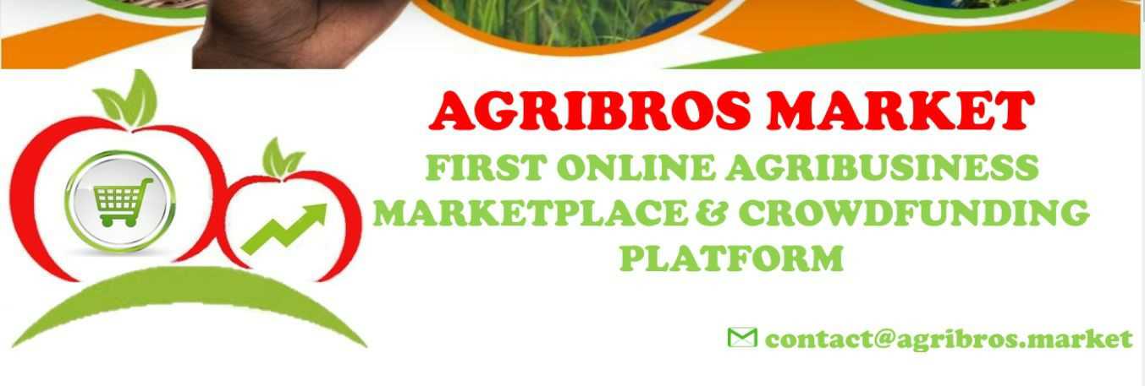

Figure 1. Agribros Logo

“AgriBros Market links supply and demand in the agri-food sector.

We work with all actors in the agricultural value chain and provide good value quality/price and high security for the buyer.

Farmers, buyers, sellers, transporters, partners, investors, and all actors in the agricultural world interact easily and simply on the platform.

It'S EASY, FAST AND SECURE.” (Agribros, 2019)

This is the explanation the site provides. After a more detailed look at the website we can say the general working is that they have nine main services which are ;

* Publication of agri-food supply and demand and launch of a fundraising campaign
* Sale, purchase, comparison, rental, and barter of agricultural products, services, inputs, equipment, and land
* Discussions and contacts (B2B, B2C, B2G, SMS-email, email-SMS)
* Call service, SMS API Subscription (USSD), and Newsletters on market price, weather information, improved seeds, business practices
* Sale of Agricultural Market Data, Trends, and Statistics by region
* Targeted advertising and marketing (digital and operational), opportunities, and news
* Agricultural training, support, advice, and support
* Production of food newspapers and magazines
* Newsletters, datasheets, catalogs, and others

From a marketplace point of view they have three options which are;

* Farmer and Argo-Supplier: Submit all information about their product(harvest), service, or project evaluated in quality, quantity, price, and cost of the project online platform or by SMS.
* Agribros Market: Connects to markets and improves farmers’ access to information, markets and finance.
* Buyer and Contributor: Consult all offers and announcements on the web, mobile, or USSD platform and order the product or contribute to the project they are interested in.

### Similarities and Differences with Our Project

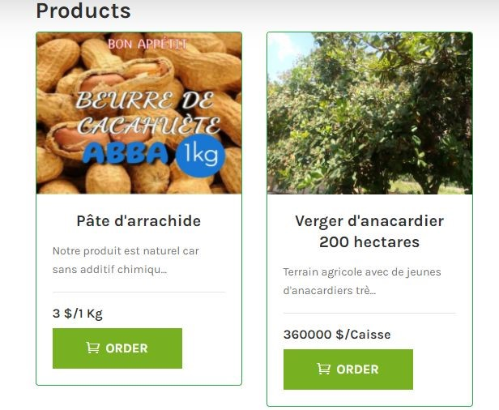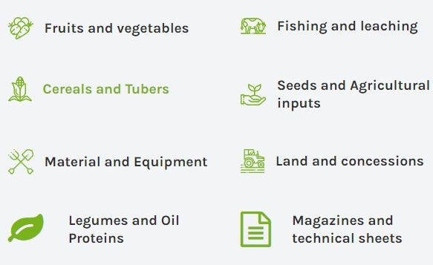

Figure 2. Agribros Website Services

Our project is not exactly like this one because this website offers its users to sell and buy products on the site. Which is not exactly our vision for our project.

Another difference is that this website has multiple other things that users can sell outside the produce products, like seeds and oil. Our project aims to build a space for specific products.

It is similar to our project because we are like this website does want to connect sellers and buyers on one platform. Which they can share contact information and complete the sale without anyone getting in between.

Another similarity between our project and this one is that we too plan to publish all the information about the product on the website so the buyers can make better choices.

## 3.2. agro-market24.eu

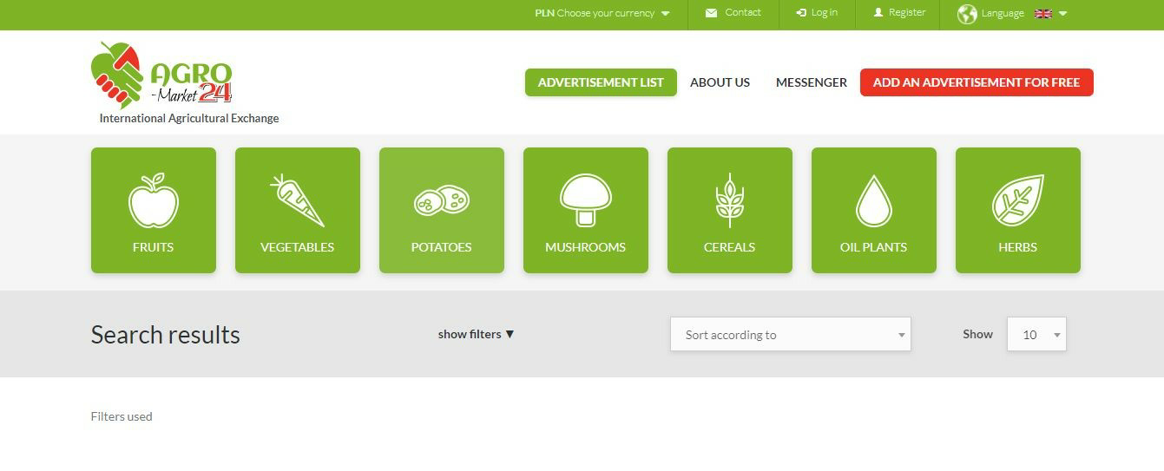

Figure 3. Agro-Market Logo

“Agro-Market24 is a modern online marketplace where you may buy and sell agricultural products. Users may offer all kinds of fruits and vegetables and easily communicate with buyers. Farmers, growers, producers, agents, and everyone else who is interested, may use the platform, quickly find interesting offers and make good deals. Agro-Market24 is an inclusive and accessible commerce platform that enables fruit and vegetable producers and buyers to participate in the worldwide online market. All kinds of farmers, growers, and agriculture producers may sell their fruits, vegetables, cereals, potatoes, mushrooms, and other crops. On the other hand, exporters, importers, and distributors may buy grain, fruit, vegetables, potatoes, mushrooms, and other agricultural products. Agro-Market24 connects millions of buyers and sellers around the world. Using the service is free. You may add as many buy and sell offers as you want. Try our product and you will find out about the advantages of buying and selling on Agro-market24. We are more modern and much more useful than competing services. Our goal is to help develop the agricultural industry in the world, especially fruit and vegetable growing. We are building stronger connections between buyers and sellers with product experiences that are fast, mobile, and secure. And we are transforming the individual selling experience to help users turn the things they produce into cash. Agro-market24 perfectly fits the modern mainstream of online media, which offers, among others, quick and precise information about available products and services as well as demand for them on the agricultural market. The most popular agricultural offers so far on Agro-Market24 are: to buy and sell apples, pears, peas, potatoes, and tomatoes. The value of the transactions made through Agro-market24 increases with each passing day. The fruit and vegetable market is very important for the entire agricultural industry. On Agro-Market24 users may find everything you need in one place: You can negotiate prices, read product specifications, view photos, chat with other users, and more. Join us and grow with us, creating added value for the agricultural industry around the world! We would like to invite you to use the Agro-Market24!” (agro-market24, 2020)

This is the information text on the website. The website has seven main product titles(fruits, vegetables, potatoes, mushrooms, cereals, oil plants, and herbs). It also offers contact information and location information of the product. Also, the advertisement date and time are visible with a picture of the product itself. The user needs to login to see the location and contact information. Every product that is being sold has descriptors to better describe the quantity and the quality of the product.

### Similarities and Differences with Our Project

This website is much more aligned with what we plan to do. What they do is offer a connection between the sellers and the buyers. Without meddling with the payment.



Figure 4. Agro -Market Search/Add

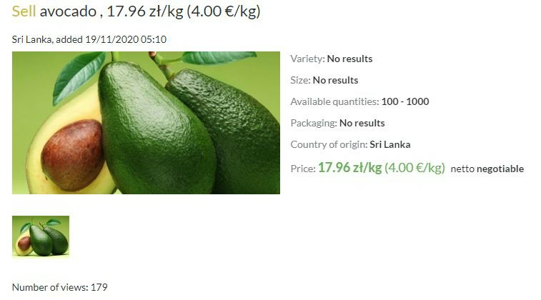

Figure 5. Agro-Market View Product

For ease of use, the website categorized the products in seven different sections which all have subsections to be even more specific about the products. Each advert on the site has the product’s name, quantity, price, and date. Also, the seller’s location and contact information can only be accessed with a logged-in account.

Users can search a product in the adverts with many filters to help sort out the exact thing they want.

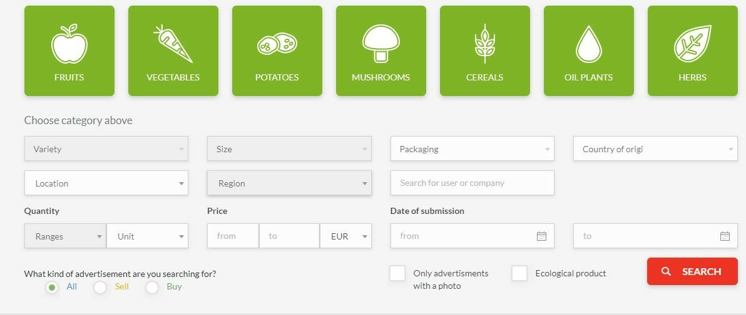

Figure 6. Agro-Market Search Filters

Users can view adverts without creating an account however, to contact the seller an account is required.

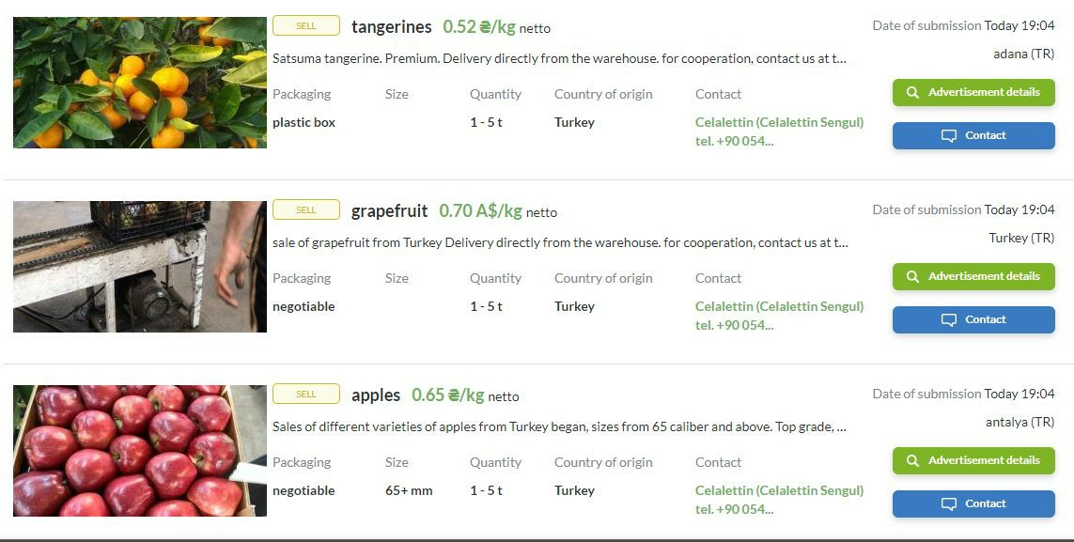

Figure 7. Agro-Market Product List

## 3.3. Wildkale**.**com

“Wildkale.com is the first online farmers market where you can order your food directly from your local farmer, have it harvested/prepared in order and receive it the next business day. You save time driving to the farmer’s market and you get better quality food with more character that is much fresher than in the supermarket. And it's always 100% local.” (Wildkale, 2016)

This is the information text on the website. There is a search bar on the first page. When you enter a zip code. Then you can see all the farmers that are a maximum four-hour drive away from the location you entered. Then you place your order which arrives at your door on the next business day. While you are ordering you can choose from farmers, fruits and veggies, dairy and eggs, meat and fish, grains and baking, local meals, pantry and coffee, and wellness options and search accordingly. You can also create an account which you choose from a seller account, a buyer account, and an affiliate account.

### Similarities and Differences with Our Project

The difference between Wildkale and our application, in our system suppliers, can filter addresses to buy items at the closest distance. Also, the supplier can see all sales in our program we are not limiting suppliers. Another difference between Wildkale and our program, we are not interested in shipping jobs Also, we are not limiting farmers like supplying dates. Supplier and farmer dealing with each other about shipping date and place.

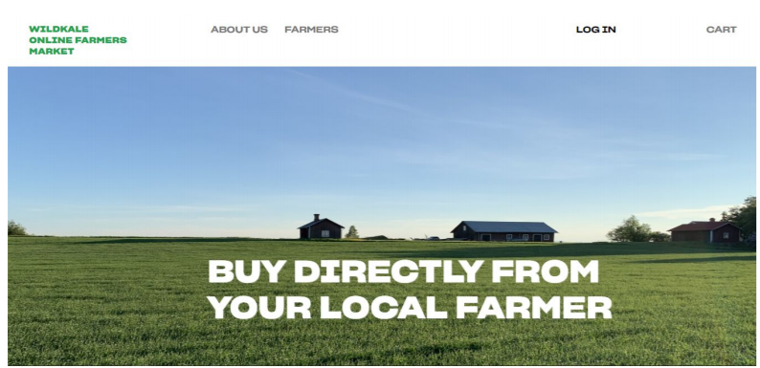

Figure 8. Wildkale Main Page

## 3.4. ditap.gov.tr

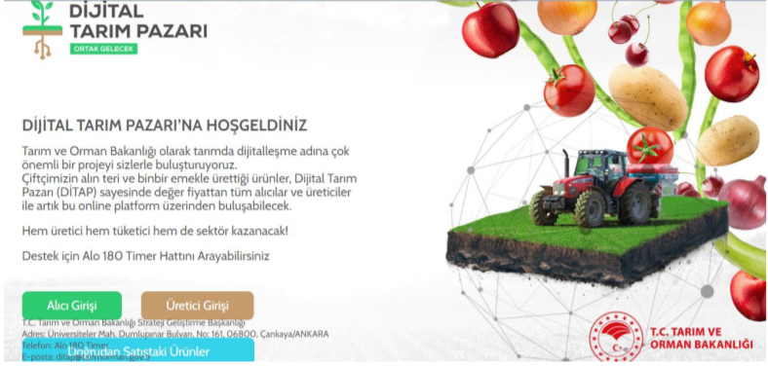

Figure 9. Ditap Main Page

“As the Ministry of Agriculture and Forestry, we bring you a very important project for digitalization in agriculture. we bring together. Thanks to the Digital Agriculture Market (DİTAP) All buyers and producers at the value price will now be able to meet through this online platform. Both the producer, the consumer, and the sector will win! " (ditap, 2020)

This is the information text from the website. It’s a government website that only has three main options. Which are buyers’ entrance, sellers’ entrance, and directly sold products.

### Similarities and Differences with Our Project

The difference between Ditap and our application, our application has more filtering options. Also, our application will give more information about farmers, suppliers, and products. Farmer and supplier account system similar. Also, Ditap works like us, they just connect people by telephone number. Our system will show the mail address and telephone number of the farmers. The sale system is very similar to our Project, sale section while searching for a product users can search with city, category, and products.

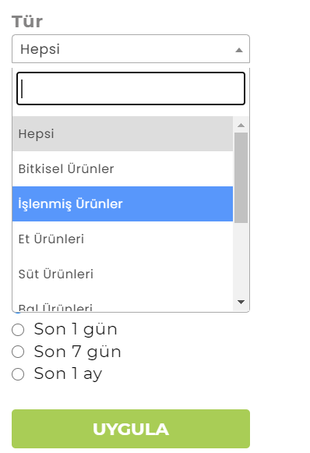

Figure 10 Ditap Search/ Filter

There is no search bar in Ditap users must find the item part by part pressing category. In our system, the search bar will be added.

## 3.5. Efarm.cm

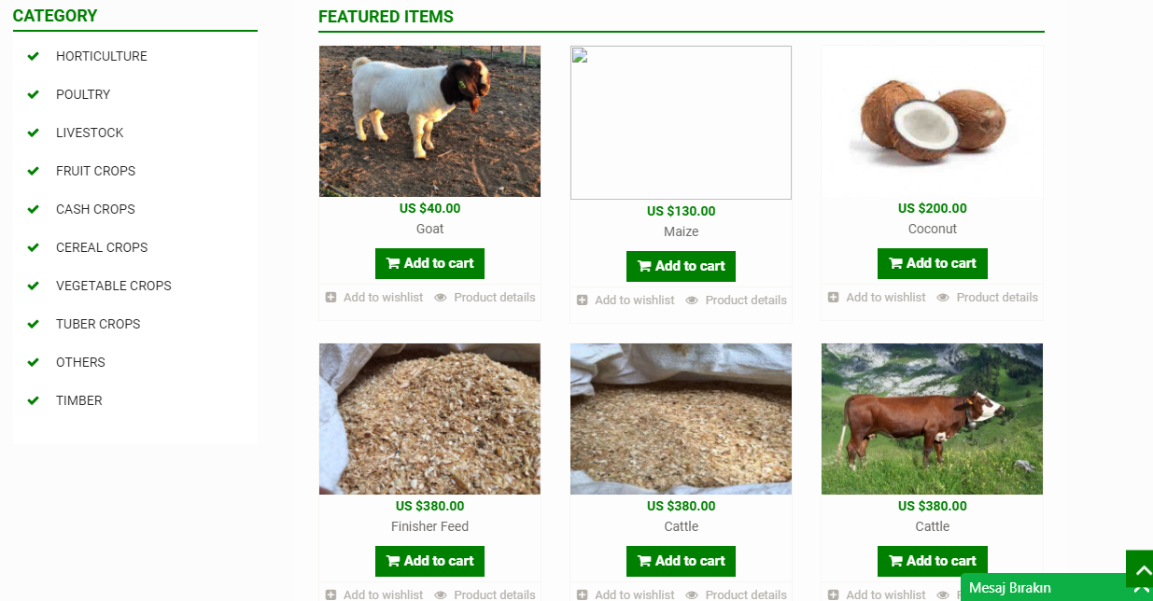

Figure 10. Efarm Main Page

“eFarm.cm powered by GericomGroup Co.Ltd is a web and mobile platform for buying and selling agricultural products. It allows access to agricultural products in Cameroon, Africa, and the rest of the world. We provide Email and SMS notifications, 24/7 online Chat support to its customers. Our goal is to provide farmers and communities and agricultural dealers in Cameroon and Africa, opportunities to market their farm products online and reach consumers around Cameroon, Africa, and the rest of the world while creating a real added value to the agricultural arena by providing an online marketplace connecting African farmers and agro-dealers to buyers around the world, growing local farmer markets into a global one. We oversee transactions from start to finish, ensuring reliability, loyalty, trustworthiness, efficiency, and saving time for either party; sellers and buyers, involved in the transaction. Our wide range of online payments makes transactions easier from our national and international payment methods (MTN Mobile Money, Orange Money, and Paypal). eFarm.cm offers traditional methods of payments like Western Union, Money Gram, Express Union, Express Exchange, and Cash on Delivery. We are secured for online purchases powered by GeoTrust.

How eFarm.cm Works

Farmers and Users with NO internet Access

1. Farmers send SMS with basic details of farm produce for sales
2. eFarm.cm call center or customer care call farmer or user to collect full details of farm products and list the products online.
3. Listed products are sold, SMS is sent to inform farmers about the sales. Products are picked up or delivered.

NO NEED FOR THE FARMER TO GO TO THE MARKET

Farmers and Users with Internet Access

1. Farmers go to the web or mobile and access www.efarm.cm or eFarm.cm mobile app.
2. Register, Login and list his/her products for sales.
3. Farm products are sold, SMS and Email alerts are sent. Farm products picked up or delivered.” (Efarm, 2015)

These are the information that the site provides to users of it. As we analyze the site more we can see that the site provides a selling platform for users. It is very different from our Project. This website works as an intermediary between buyers and sellers in a global area. It provides shipment to buyers.

### Similarities and Differences with our Project

It differs by;

* It works as an intermediary between users of it.
* It provides global shipment offers.
* Payments are made on the website, not directly to the seller.
* Also, there are adverts for animals like goats, cattle.
* Our Project aim is on the local area, but this site offers a global market.
* The site Works directly with sellers, and communicates with them as a middleman, our Project does not involve a middleman.

It is similar by;

* Users create an account as buyers or sellers like our Project.
* There are different categories for different types of products.
* Details of products are explained descriptively, it points to availability, stock of product.
* Also, there is a section for special offers, a discount section for special items as sellers mentioned.

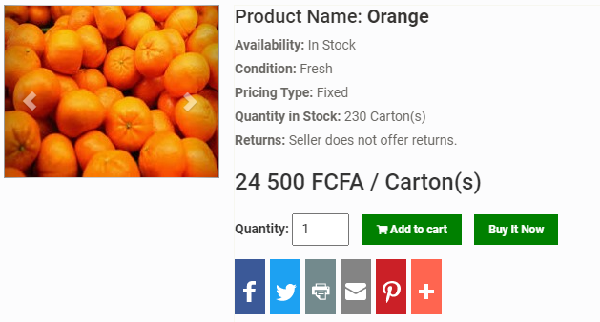

Figure 11. Efarm View Product

## 

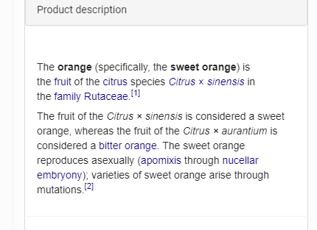

Figure 13. Efarm Product Description

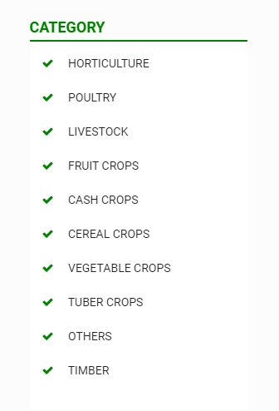

Figure 12. Efarm Product Categories

## 

## 3.6. Tarimziraat.com

This is a local website as well, just not a government base one. It operates with nine clickable buttons with different functions. Which is Main Page, Agricultural Products, Applications, Adverts, Supplements, Shares, Up to Date(Stock market and marketplace prices), Log In, Contact. Our main focus should be on the adverts because it is most similar to our project. On this website adverts have three optiıons; Last adverts, Search adverts, Make Adverts. When we click on the last adverts a list of products appears. Then when we click on any particular one its descriptors, seller information, and seller’s contact information appear. Search can be done by sellers, buyers, product name, category, and city name. And to make an advert user must be a registered user. So, if not a registry page appears.

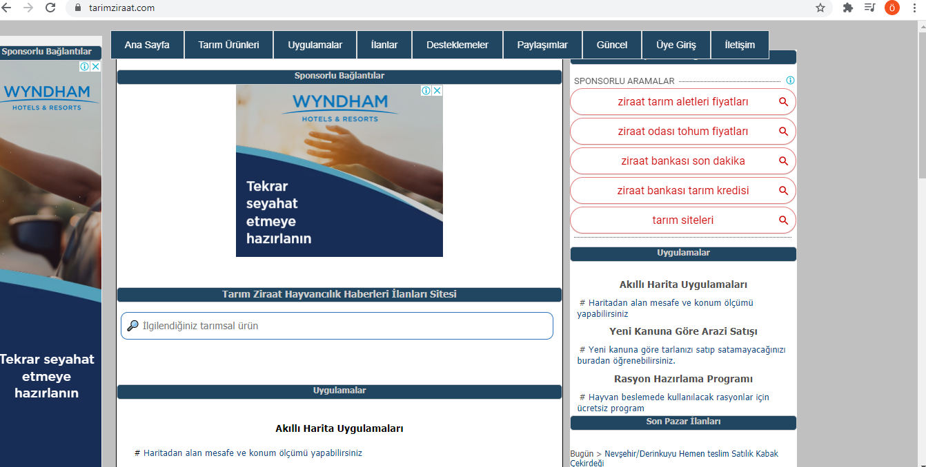

Figure 14. Tarimziraat Main Page

### Similarities and Differences with Our Project

It differs by;

* This site provides other selling options extra like selling fields for farming, goat, cattle.
* There is a section for applications on the website, a smart map application, land sell options, and two more extras.
* There is a section for the buying market, users open the topic for what they need, and they add their descriptions for what they need specifically.

It is similar by;

* It has a forum, for prices, what kind of products are high quality, which product produces how much in a year, these are some of the examples in the forum.
* Adverts are very similar to our Project, in the advert section while searching for a product users can search with city, category, and products.
* The accounting system is similar to our Project, to give an advert user must create an account.
* Features of adverts are detailed on this website, in our project we aim to create a more detailed advert description.

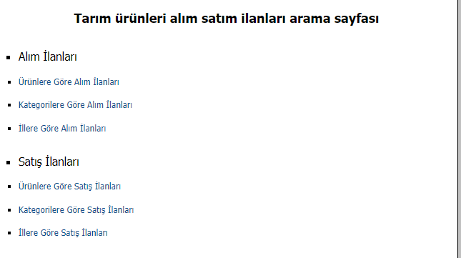

Figure 15. Tarimziraat Advert Choices

# 

## 

## 3.7. PULLUK.COM

Pulluk.com the website is the address of those who carefully grow their products until harvest time and make their living from production. This is a system that manufacturers can benefit from. It is designed for producers whose only concern after receiving their harvest is to be able to deliver their products at their true value. If farmers cannot reach the right buyer and earn the fee they want, they are matched with the right buyers through this site and sell their products to the most suitable offer.

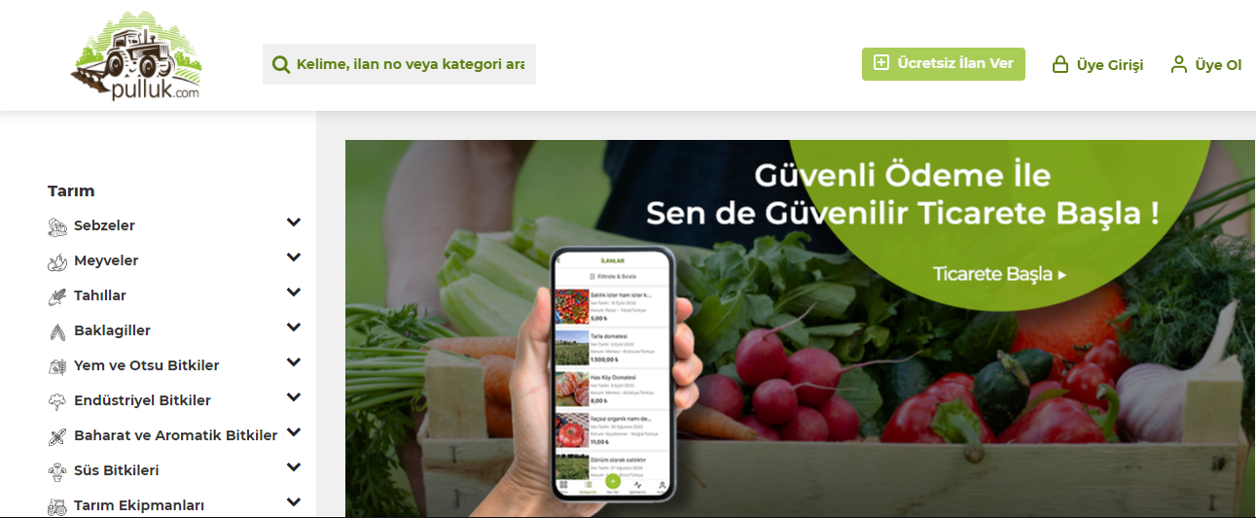

Figure 16. Pulluk Main Page

After completing membership on the website, the first step is to select a Category. After selecting the main category, it is necessary to select the subcategories that are most suitable for the product. After uploading photos of the product you want to advertise at a later stage, the uploaded photos are checked during the advert approval phase, and images that are of poor quality or do not reflect the product do not pass the ad approval. After entering the ad details in the required fields, you can enter the product description text and complete the ad creation process. In the purchase transactions, the bid is given by entering the announcement detail. Your offer must be answered within 3 days by the seller. Unanswered offers are automatically canceled. If your offer is accepted, the notification will come, and you can see your bids that have turned into orders by clicking on the notification or clicking on the “products I bought” tab in the “my orders” section of your profile.

### Similarities and Differences with Our Project

In our project, no announcement can come to the forefront and there is no fee for it. But pulluk.com sellers who want their products to appear in the foreground on the website make their products appear more for a fee. This system is called doping and anyone can use it. The other difference is that this site sells fish, agricultural equipment, and animal products. But our project does not include these categories. Finally, payments are made through the website, but in our project, payments are made directly to the seller, and we do not have any payment options on the website.

As for similarities, users create an account as buyers or sellers, such as our project. These two websites allow you to place ads for free. They also aim to enable farmers to sell their products at the best price and increase the farmer's earnings, Finally, in both projects, the sites offer different kinds of products to their users.

## 3.8. Çitfçideneve.com

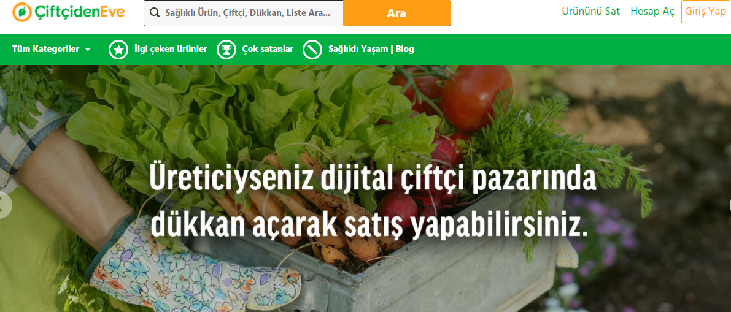

Figure 17. Çiftçideneve Main Page

With the natural and organic products, the market created by bringing together reliable farmers to produce natural and organic products, we can easily access organic products produced by homemade or traditional methods, without the use of additives. Each region of our country is very rich agriculturally, local producers are reached, they are visited and production work is closely observed. Our farmers, who love their work and add their love to their products, are also allowed to know us. With çiftçidenve, where you can safely order the foods you consume for yourself and your family, both healthy and natural production is supported by our farmers. In this way, we can add to our lives a lot of products that you may no longer find and miss by joining this natural environment. This project was implemented primarily to eliminate the high intermediary share in the prices of products. Their main goal is for farmers to be sustainable in producing healthy products in their natural environment. We know that farmers, when they share their earnings with intermediaries, that is, when they do not get the return of their labor, will have to work to increase the yield of the field, rather than growing healthy crops. This means more chemical fertilizers, more pesticides, more hormones. In other words, we can say that more unhealthy products will continue to meet our kitchens, as they still are.

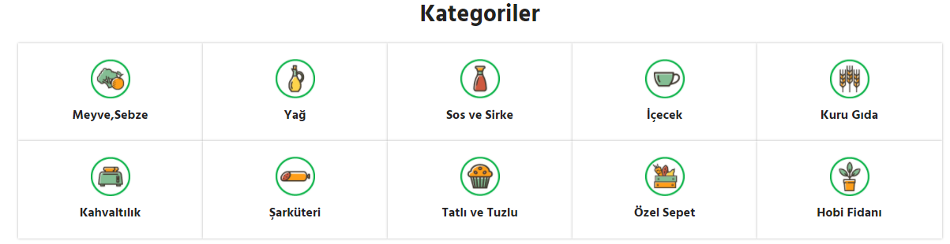

Figure 18. Çiftçideneve Categories

## 

### Similarities and Differences with Our Project

Çiftçideneve marketplace receives a service fee from sellers for all products sold. But there is no paid system in our project. Payments are made on the website, not directly to the seller. However, in our project payments are made directly to the seller there's no payment option on our website. Finally, on this website meat and seafood are sold, but these products will not be included in our project.

Users create an account as a buyer or seller, such as our project. Also, both websites aim to eliminate the commission problem, to bring higher income to the farmer, and to increase the product quality. Finally, in both projects, the sites offer different kinds of products to their users.

# METHODOLOGY

## 4.1 Requirements Specifications

### 4.1.1. Functional Requirements

#### Registry

Request Description

Users should register with their name, password info for access to the System. All users must have their accounts because FarmLife is an online food sale system. Farmers and user items and addresses will Show differences also the system must keep user accounts safe that’s why all users enter the system with their passwords. Because accounts must be private.

Effect if declined (Risk if the project request is declined)

Farmers cannot track their items and there is no privacy for users. Also, tracking their items becomes more difficult. Another problem farmers must enter their addresses and personal Info each time listing something inside the system.

Request Alternatives

All online sales systems need user accounts; this requirement must be in our application. Another alternative using a more complex registration system and account system but it’s not necessary.

#### Return to User

Request Description

The system should return to the user who entered any strings to the search bar, the best results with the corresponding items.

Justification

Online sale systems must have a search bar. Users use that bar to find their interests easily. Also, the system must give the best results according to user inputs. If the system does not have this function, the user does not want to use that system.

Effect if declined (Risk if the project request is declined)

Users cannot find their interests easily; they must look at a lot of irrelevant items to find their interests. This takes more time and customer satisfaction decreases.

Request Alternatives

Our system can use other options like selecting part by part but it's taking too much time. For example, a customer searching for a Royal Gala apple. Customers must select the fruit category after selecting the apple category then select Gala then select Royal Gala. Entering Royal Gala in a search bar is more efficient and easy.

#### Show Progress

Request Description

The system should save the progressions of the users, allowing them to see progressions, information, and personal products.

Justification

Farmers will list items or users will enter info that must be saved. The program must save these progressions.

Effect if declined (Risk if the project request is declined)

If the system cannot save progressions farmers cannot list items and the aim of the project cannot be completed.

Request Alternatives

It's a necessary feature there are no alternatives to this function.

#### Expiration Date

Request Description

The adverts which are past due their expiration date should be deleted from the system. Even without the seller’s interference.

Justification

Sellers can forget or ignore the fact that their products are not in a good shape anymore and selling spoiled food is unacceptable so the system should work for both the sellers and the buyers benefit by deleting the outdated adverts.

Effect If Declined(Risk if the project request is declined)

Spoiled food is not a quality product and not selling quality products would hurt both the seller and the site’s credibility.

Request Alternatives

The deleting can be up to the seller however this is not entirely secure because bad intentions and plain forgetfulness can be a big problem. Another option can be placing a warning message on the outdated adverts instead of deleting them.

#### Baseline Descriptors

Request Description

The adverts should have baseline descriptors that must be filled in to be published.

Justification

To ensure that buyers get the most basic information about the thing they are buying we should hold the seller accountable for providing that information.

Effect If Declined(Risk if the project request is declined)

Buyers can have misinformation about the sold products and that would cause disagreements

between the users on both ends of the spectrum, the sellers and the buyers.

Request Alternatives

We can add a request information feature for the missing information that might be on the advert. However, requesting the sellers to provide it in the first place would be a quicker solution.

#### Filtration

Request Description

The search system should have an adequate filtration system.

Justification

The very main thing that users expect from this site/application is to find the product that fits their criteria. To do that the search function should have a good filter system that categorizes the products that are being sold on the site.

Effect If Declined(Risk if the project request is declined)

It’s a very essential feature that this app must-have. The absence of it turns this project into an entirely different thing.

Request Alternatives

There are no adequate alternatives for this feature.

#### Categories

Request Description

The system should have categories about products to select what buyers need

Justification

In online sell systems, there should be a category for products to categorize them easily. If the system does not have a category for a product, it will become complex and difficult to use.

Effect if declined (Risk if the project request is declined)

Users can not find what they search for easily, and they will be forced to search through one by one according to what they need.

Request Alternatives

A category for products according to their type to ensure that users will find what they search for.

#### Update/Remove

Request Description

A product sold to the user will be updated and removed from the product list.

Justification

The fact that the product sold remains in the system can lead to a problem and give a bad impression on the system.

Effect If Declined(Risk if the project request is declined)

There may be customers who request to receive the product sold, and their request is considered invalid because the product is not in stock. In terms of customer satisfaction, it becomes a bad situation.

Request Alternatives

The initiative should not be left to the user and the product sold should be deleted by the system.

#### Price Change

Request Description

The system must give the seller the right to change the price.

Justification

At times, the seller may want to change the price. It can increase or decrease the price depending on the situation.

Effect If Declined(Risk if the project request is declined)

The seller can't sell at the price they want or it may not be able to find a buyer because of the price of the product.

Request Alternatives

The seller must have the right to change the price and be able to update it at any time.

#### Ranking

Request Description

The system must rank the products that the buyer is looking for by the date of announcement

Justification

The customer may want to see the latest ads because they may doubt the freshness of the product

Effect If Declined(Risk if the project request is declined)

If the customer cannot do this ranking, it will be difficult to find the product he wants, and the efficiency he receives from the system will decrease

Request Alternatives

There is no alternative for this feature.

### 4.1.2. Non-Functional Requirements

#### Availability

The system will be available all time for the users and can be reached 24 hours a day and 365 days a year. The system shall be operational 24 hours a day and 7 days a week.

#### Accuracy

The system should accurately provide real-time data taking into consideration concurrency

#### Efficiency

If the system fails or crashes, the system should recover back up to normal within less than one day.

#### Security

The users’ information must be protected given that phone numbers and addresses are very personal information that can create security threats.

#### Usability

This system should be easy to use for everyone and makes sense for what it does.

#### Scalability

The system should be able to grow in size to accommodate the growing data.

#### Performance

The system must interact in under 3 seconds to not lead to a negative user experience on the system.

#### Privacy

The system should ensure that the private information requested while registering on the system remains confidential.

#### Functionality

The system must be functional and give its users a good experience.

#### Flexibility

The system must be changeable per the opinions received by customers and vendors.

#### Robustness

The system must remain intact regardless of the number of user entries and should not cause problems to users

## 4.2. Design Specifications

### 4.2.1. General Description

#### 4.2.1.1. Product Perspective

The objective of our project is to make an online sale platform between farmers and buyers. Our main aim is to prevent intermediaries from making an unfair profit from producers, sellers, and customers. For this reason, our website provides contact information of the seller to the buyers and easy access to the farmers for the buyers.

We are planning to develop a website for this project because using websites is very easy for users. Update and setups not necessary for users sometimes configuration of desktop applications can be a problem however in web site users do not face these problems. Also, a user must connect to the internet because this project is similar to an E-commerce program.

#### 4.2.1.2. General Constraints

We are expecting buyers to know the name and type of the product they are searching for. We are expecting sellers to provide enough information for their products. Also, we are expecting users to come to an agreement between themselves about the sale.

#### 4.2.1.3. Assumptions

Our main assumption is that using websites like our project is aiming to create makes mediators null. And this is a profitable solution for everybody. Also, we are assuming an agreement can be achieved between sellers and buyers without the forcing hand of a website or that said mediator. Also, we are assuming the best possible platform for this service is via a website. The reason for this is that the sales of the product depend heavily on the looks of the products and by design mobile phones are smaller than computer screens and cannot provide the adequate screen to view the details of the products. Hence, a website is the most suitable medium for this project.

### 4.2.2. Screen Flows

#### 4.2.2.1.Main Page

On the main page of our site, our users can examine our products and search the product according to categories, also they can use the search bar. In addition, they can reach us in our contact information below on our site. Farmers who want to give products to our site also can reach us there. If users want to buy products, they must log in using their account. If they don't have an account they must not register. They should register with their e-mail address

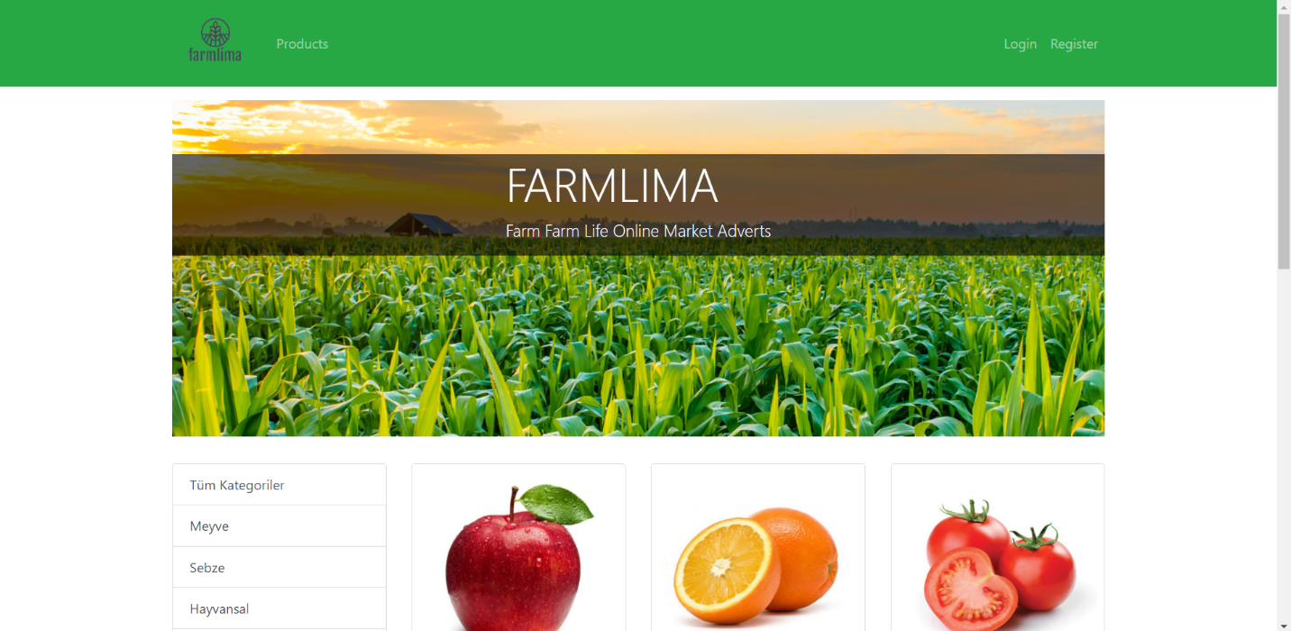

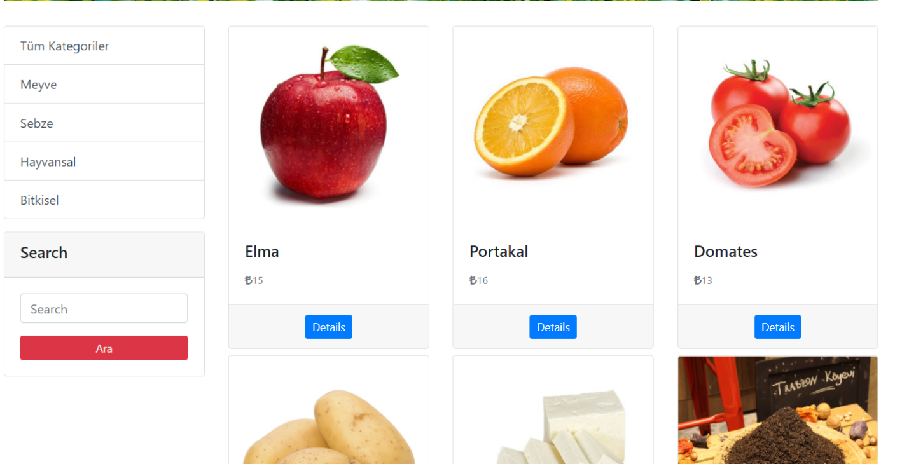

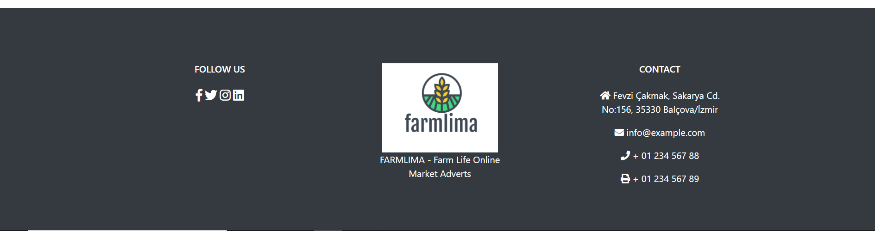

#### 4.2.2.2.Login

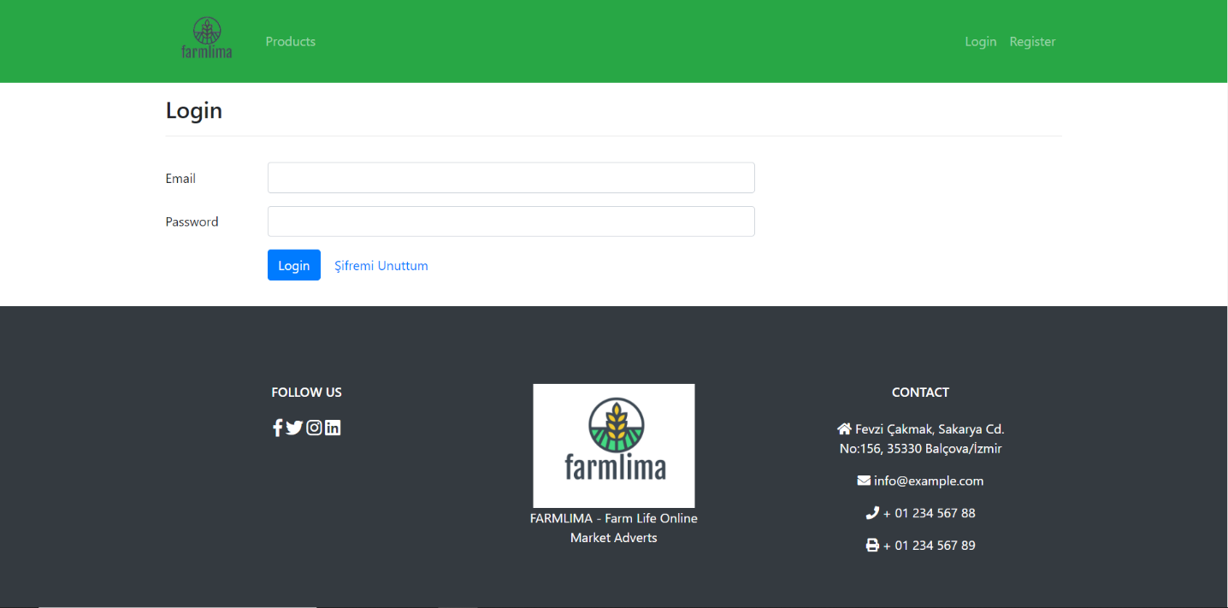

#### 4.2.2.3.Register

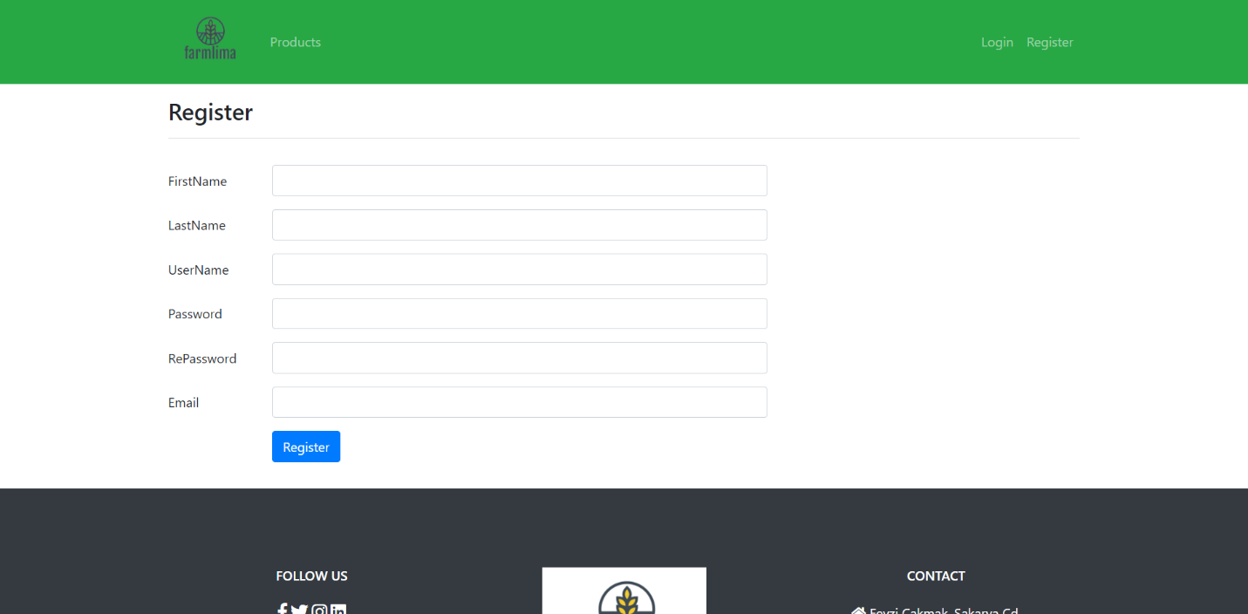

#### 4.2.2.4.Shopping Cart

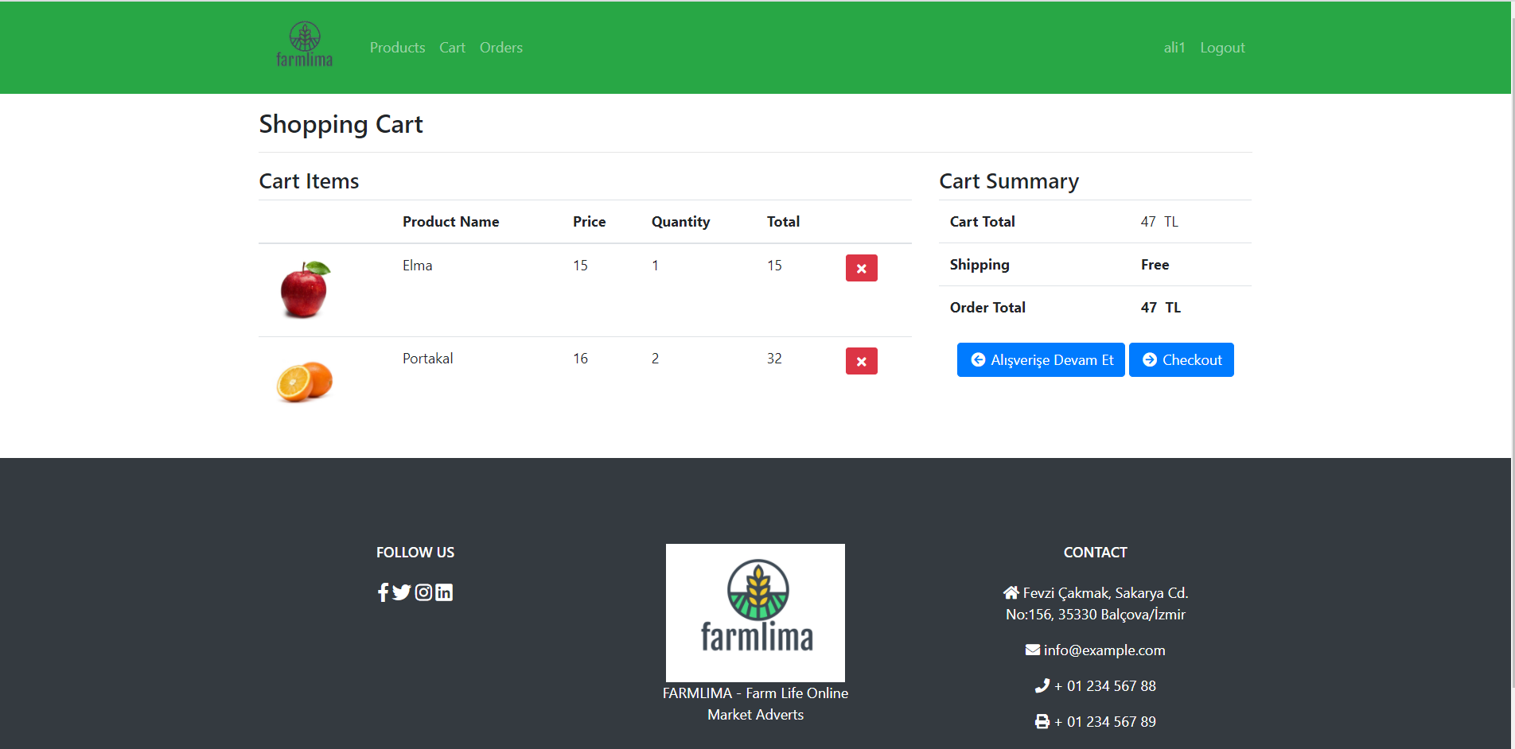

After adding the product to the cart, the user must go to check-out to make a purchase. In check-out user must enter credit card information’s to finish the shopping. After payment user can examine his order details in order detail section.

#### 4.2.2.5.Check-Out

#### 

#### 4.2.2.6.Order Details

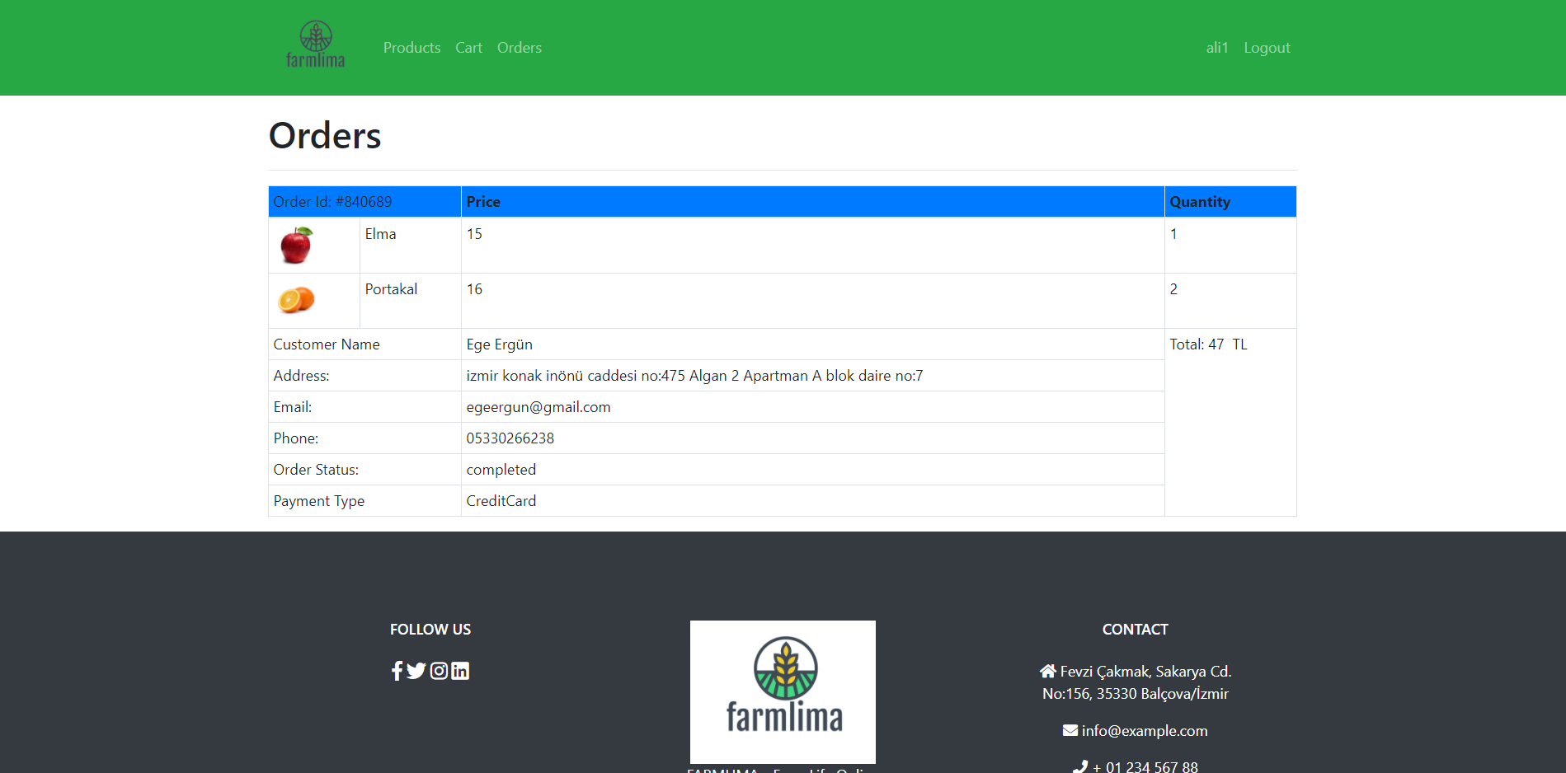

#### 4.2.2.7. Product-Edit

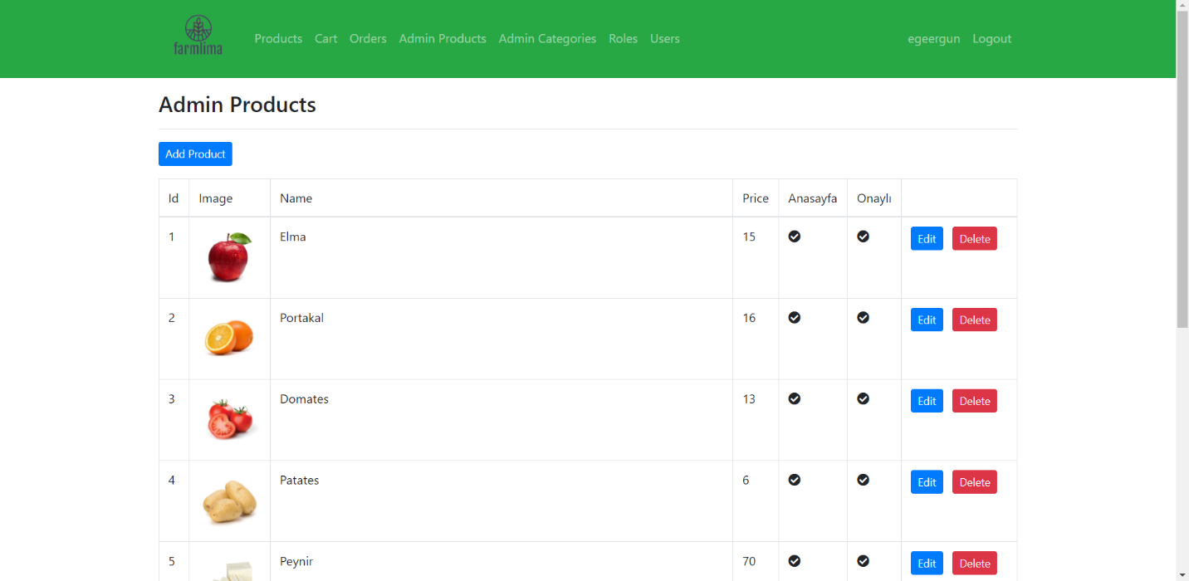

Admin has extra features, according to the user, the admin can add the product and edit the product as he/she wants, also the admin can delete or edit the user and create new categories. Also Admin can make user’s admin.

#### 4.2.2.8. Product-Edit-Detail

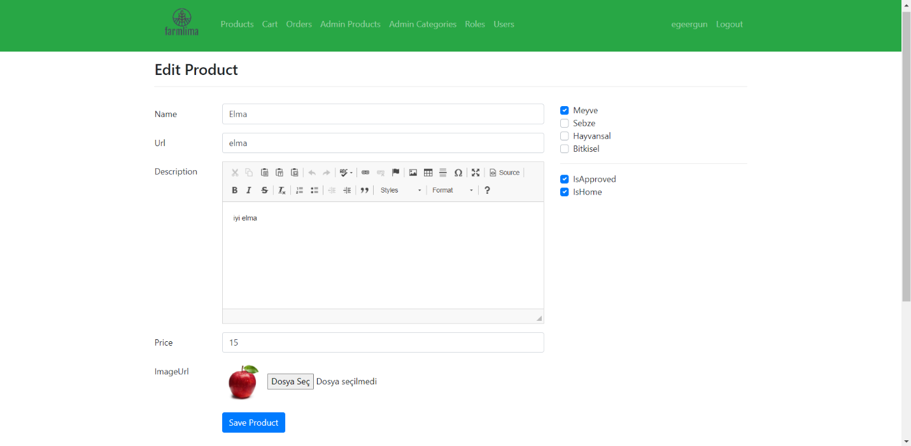

#### 4.2.2.9. Edit Role

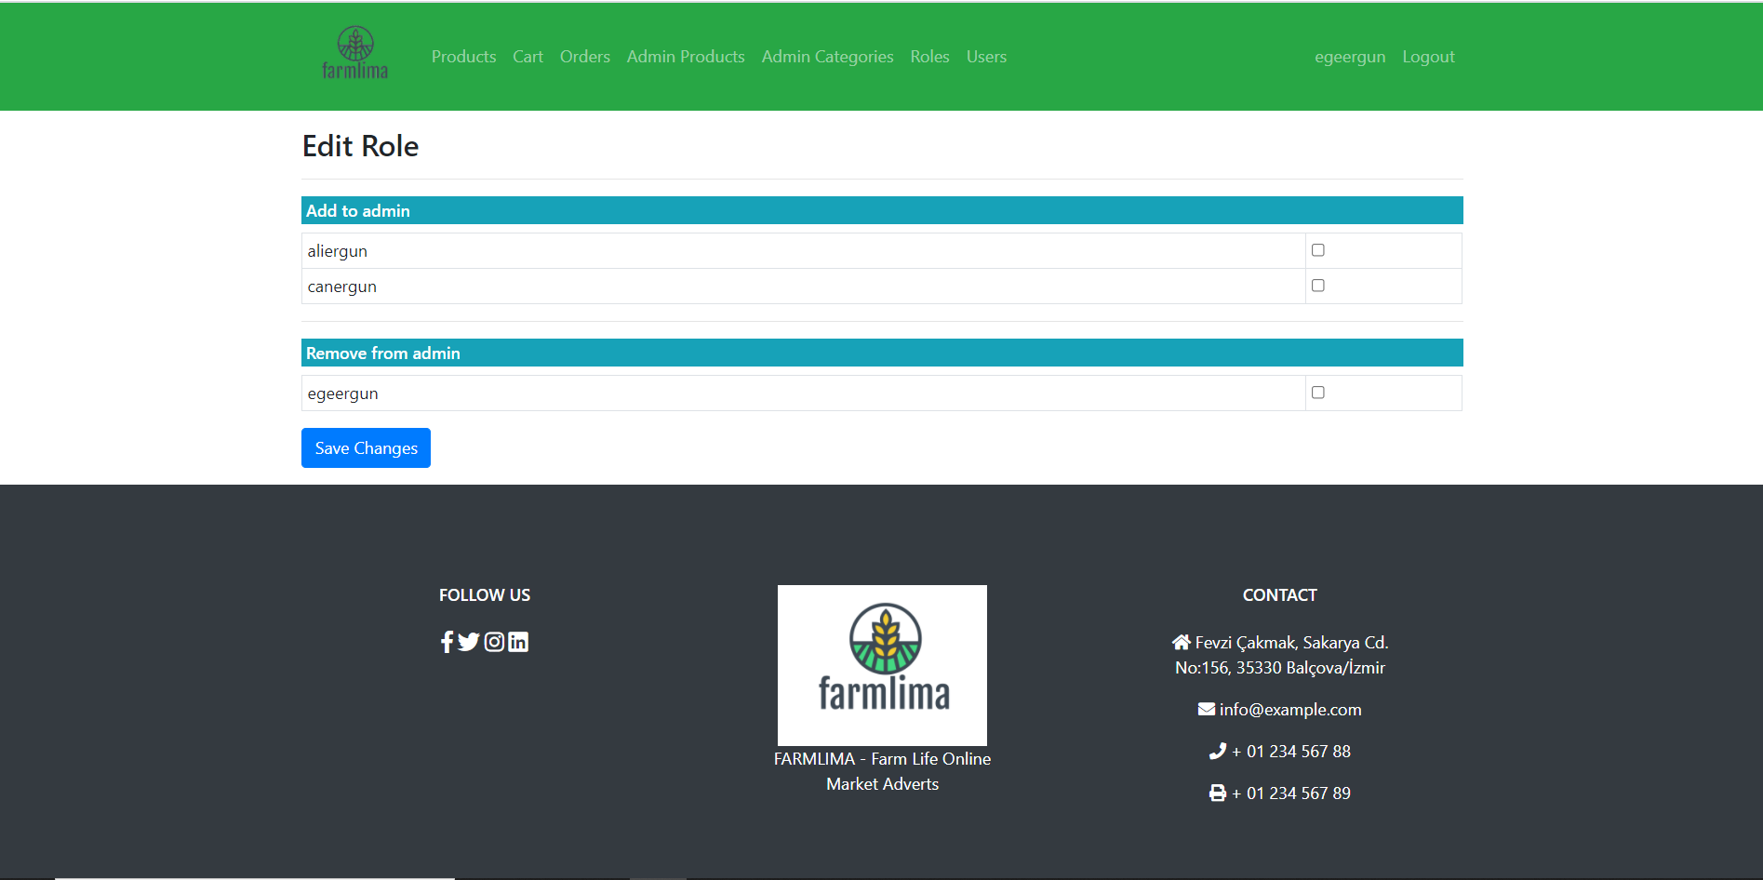

#### 4.2.2.10. User List

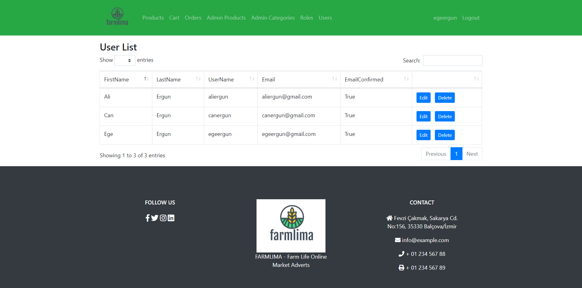

#### 4.2.2.11.Product List Page

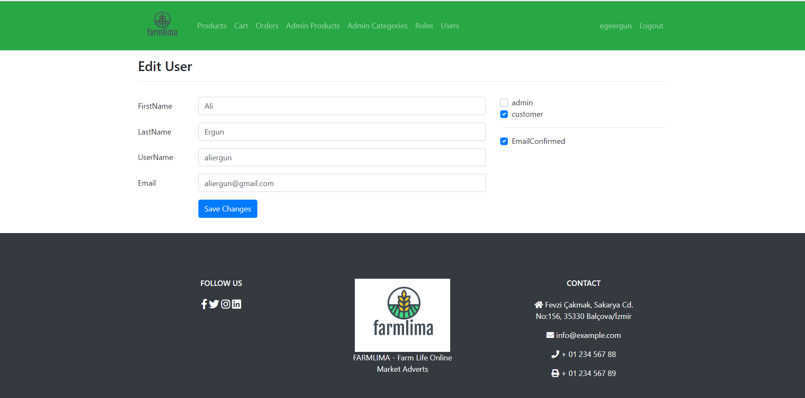

### 4.2.3. Design Details

#### 4.2.3.1. UML Activity Diagram

This diagram provides information about the operation of the program. After signing up for the system, the user will login and the customer can do things like search for the product they want, put filters on their products according to their criteria, or add them to their favorites. He can then purchase the product by contacting the people who sold the product. If the person using my program is a seller, they will have the right to put the products on the site, add location information, add pictures and add contact information in the most up-to-date form. Sellers can see the products they put on the site and remove or update the products they want. Finally, the program will allow users to update their profiles at any time. Users will be able to change their passwords and personal information at any time.

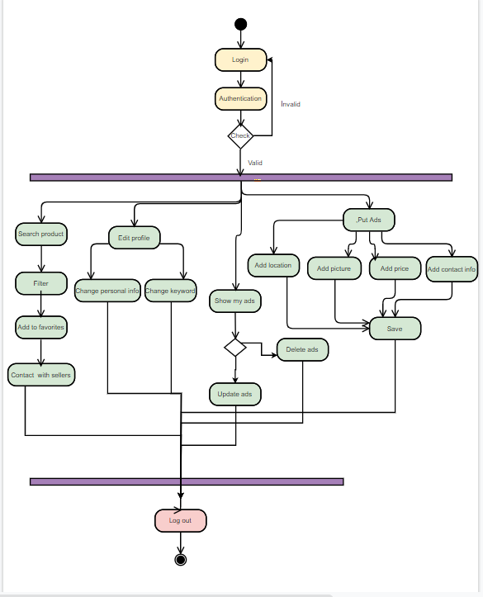

Figure 32. Activity Diagram

#### 4.2.3.2. Data Flow Diagram

##### 4.2.3.2.1. Context Diagram

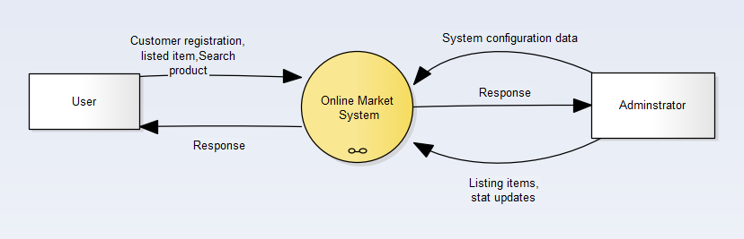

Figure 33. Context Diagram

First users register the system after the user can use the system Listing a product or searching a product. The administrator must check the listed items before putting them in a list because some users can list inappropriate or not legal things in the marketplace. The administrator must check that data.

##### 4.2.3.2.2. Data Flow Diagram Level 0

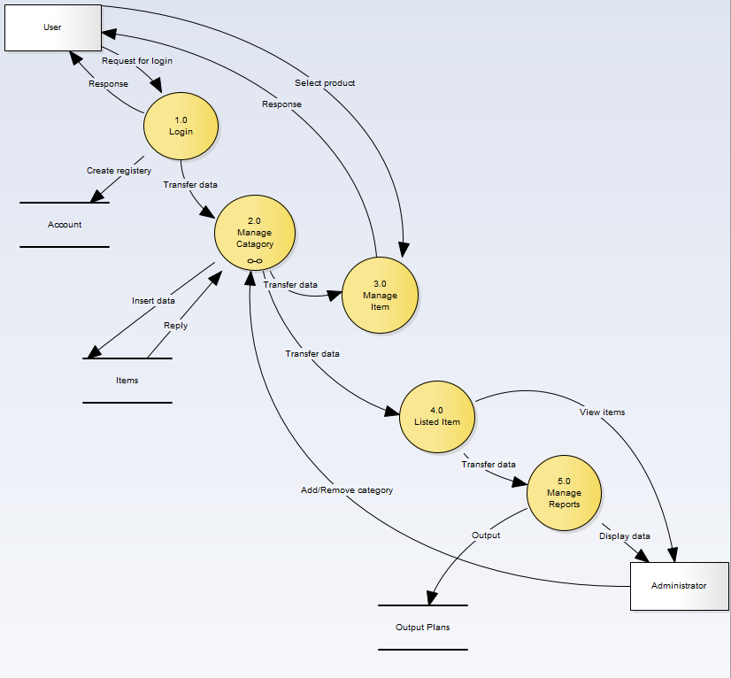

Figure 34. Data Flow Diagram Level 0

##### 4.2.3.2.3. Data Flow Diagram Level 1

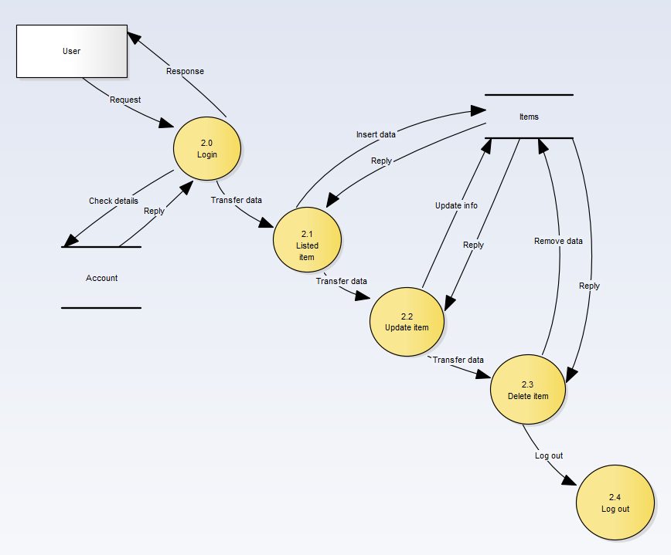

Figure 35. Data Flow Diagram Level 1

#### 4.2.3.3. Network Diagram

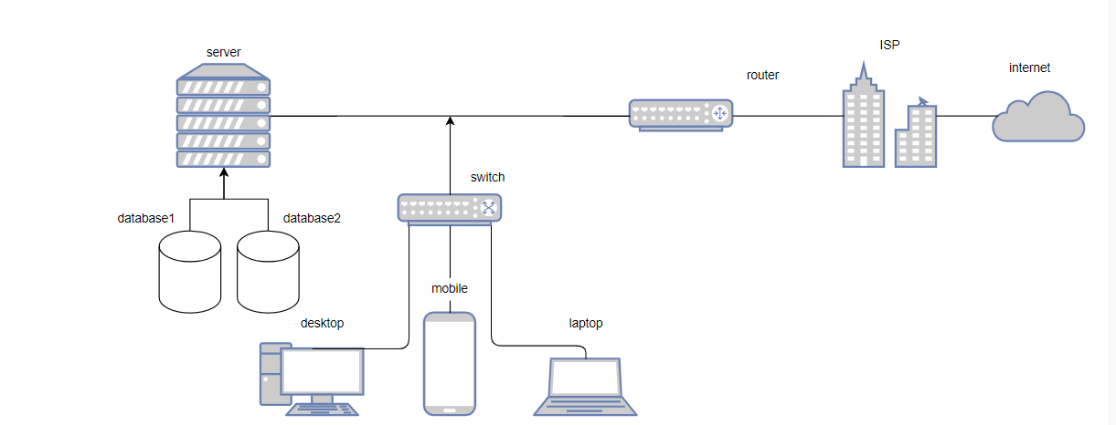

Figure 36. Network Diagram

#### 4.2.3.4. Class Diagram

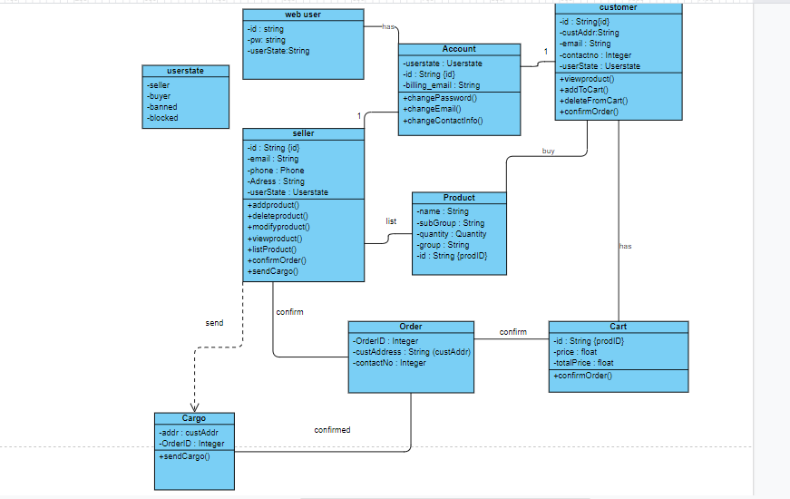

Figure 37. Class Diagram

#### 4.2.3.5. Use Case Diagram

##### 4.2.3.5.1. Use Case Diagram Main Page

This diagram also describes the main page of the website. When a user enters the site the first thing they see is a login screen asking for their username and a password. If the user is not registered they are directed to a registration page that asks them to provide a name, password, email address, phone number, and address. If the user has forgotten their password they are directed to a page that helps them recover their account. Besides that, a registered user can also update any of the information they have provided.

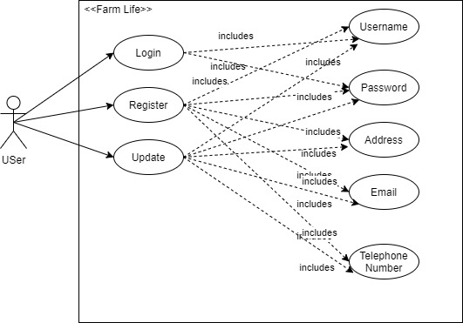

Figure 38. Use Case Diagram Main Page

##### 4.2.3.5.2. Use Case Diagram User Interactions

This diagram shows how a user(a buyer or a seller) can navigate the site. They can view a product for detailed information, search for a specific product by date, type, location, name, and price and add a product to their wishlist if they are a buyer. And for a user that is a seller, they can search for a product the same as a buyer, add a new product to sell, delete a product that they are selling, update the information on a product they are selling, view a product and add products to their wishlist.

##### 

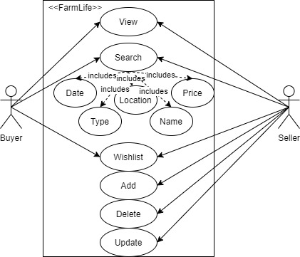

Figure 39. Use Case Diagram User Interactions

##### 4.2.3.5.1. Use Case Diagram Admin Interactions

This diagram shows how an admin can navigate the website. Same as the other user admin can login. But apart from that, an admin has the authority to add, delete, edit a category, or an advert. Also, the admin can block a user. These privileges separate an admin from a normal user and provide a more secure and appropriate website for everyone.

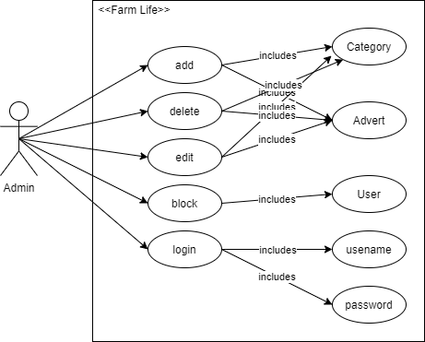

Figure 40. Use Case Diagram Admin Interactions

# CONCLUSION

Our aim for this project is to create a platform where farmers can advertise their products and connect with buyers without any intermediaries so that all the profit from the sales goes directly to the farmers.

For this document, we first explained what exactly is the problem and what is our motivation. Then, we explained what has been done to help fix this problem and which of these solutions we plan to incorporate into our project.

Then, we explained the design details of our project. The first thing was listing functional and non-functional requirements for the project. Then comes the brief explanation of our end product. We added some screen flows of mock-up versions of our project. After that, we added UML Activity Diagram, Data Flow Diagram, Network Diagram, Class Diagram, and Use Case Diagram to better explain the details of the project.

Finally, our expectation from this project is to create a platform that helps bring some form of equality to the farming industry. A transparent platform that is not a burden to the farmers.

# REFERENCES

Agribros. (2019, 04 16). Agribros.market. Retrieved 11 25, 2020, from https://www.agribros.market/

agro-market24. (2020, 2 25). agro-market24.eu. Retrieved 11 25, 2020, from https://agro-market24.eu/

Çiftçideneve. (2013, 08 1). çifçideneve. Retrieved 11 25, 2020, from https://www.ciftcideneve.com/

ditap. (2020, 09 22). ditap. Retrieved 11 25, 2020, from https://ditap.gov.tr/

Efarm. (2015, 12 6). Efarm. Retrieved 11 25, 2020, from https://efarm.cm/

Pulluk. (2019, 02 11). pulluk. Retrieved 11 25, 2020, from https://www.pulluk.com/

Tarimziraat. (2019, 12 15). tarimziraat. Retrieved 11 25, 2020, from https://www.tarimziraat.com/

Wildkale. (2016, 12 2). wildkale. Retrieved 11 25, 2020, from https://wildkale.com/